

**Optical telecommunication networks**

**Project:**

**Grooming and regeneration**

Spring 2020

**Project objectives :**

Analyzing the effect of regeneration and traffic grooming on network power consumption.

**Architecture of ROADM node :**

Each ROADM node is equipped with an all-optical wavelength switch fabric where any wavelength on any ingress/egress port can be dropped/added (i.e., full flexibility). Transponder Cards (TC), Line Cards (LC), Grooming Cards (GC), Client Cards (CC), and Regenerator Cards (RC) are the five types of cards available at a ROADM node to provide various functionalities. A ROADM node can support multiple cards of each type.

A TC has multiple client interfaces (ports) on the client side which are connected to client network elements, and a DWDM wavelength interface on the line side which is connected to the wavelength switch fabric. Therefore, it can take multiple lower rate client signals and multiplex them onto a single DWDM wavelength channel.

A CC also has multiple client interfaces (ports) in the same way as a TC, however, the line side of a CC is a backplane interface designed to be plugged into ROADM nodes’ electrical backplane. It takes multiple lower rate client signals and sends them to a GC through the backplane interface for grooming.

A GC is only equipped with a backplane interface. It has a built-in electrical switching fabric. It is electrically connected with multiple CCs and LCs through the backplane. It performs grooming for the traffic received from CCs and LCs. After grooming, it forwards local drop traffic to the corresponding CC, and forwards outgoing traffic to the corresponding LC.

A LC has a backplane interface on one side, and a DWDM wavelength interface on the other side that is connected to the wavelength switch fabric. It receives the groomed traffic from the GC and multiplexes them onto a single DWDM wavelength channel.

A RC has a DWDM wavelength Interface on each side. It receives a DWDM wavelength channel signal from the wavelength switch fabric, performs O-E-O regeneration, and then sends the signal back to the wavelength switch fabric through the same or a different DWDM wavelength channel.

Note in our architecture, both the wavelength switch fabric and all five types of cards support bidirectional traffic. Therefore, the description above also applies to the reverse direction. For example, the same TC can also receive traffic from the DWDM wavelength channel and forward it to multiple client ports.

Figure below shows a two degree ROADM in which four wavelengths are multiplexed on a single fiber. As shown in the figure, a wavelength optically bypasses the node if it is not required to be regenerated or switched (groomed) at the node.

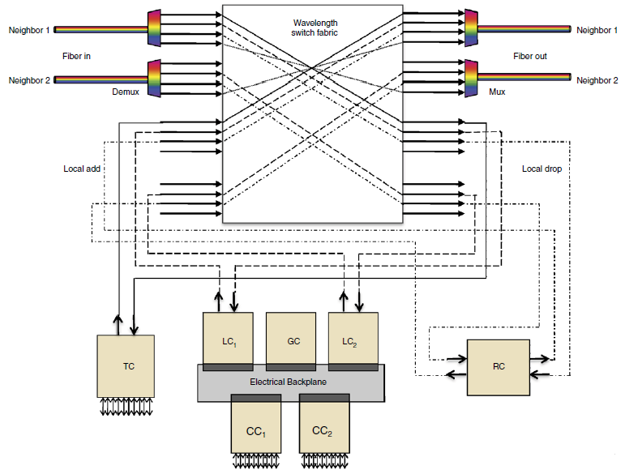

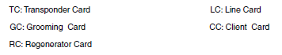

**Project Instructions :**

1- Consider the following six-node network. The capacity of each wavelength is 10Gbps and assume that the optical reach is only one hop, in other words, The signal can only be transmitted one hop without regeneration. And the architecture of each node in this network is the same as the architecture mentioned in the previous section.

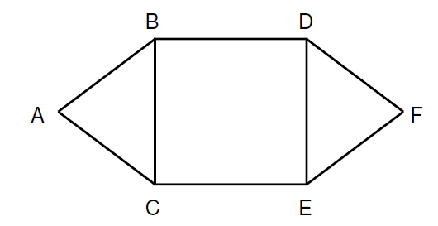

2- Consider the following traffic requests:

|  |  |  |  |
| --- | --- | --- | --- |
| rate | destination | source |  |
| 3Gbps | F | A | 1 |
| 5Gbps | F | B | 2 |
| 2Gbps | F | C | 3 |

3- Consider the cost of equipment used in the network as follows:

|  |  |  |  |  |  |
| --- | --- | --- | --- | --- | --- |
| Cost ratio | | | | | Rate  (Gb) |
| Line  card | Client  card | Grooming  card | Regeneration  card | Transponder  card |
| 0.6 | 0.6 | 1.2 | 2 | 1 | 10 |

Using Python, simulate the network for the following three cases, calculate the energy consumption of each section, and finally compare.

(a) In the first case, suppose only the regenerator is used in the network regardless of the grooming. Consider the most optimal case according to the given requests and calculate the number of tools and equipment used and the power consumption as follows:

Total power consumption = (number of TC * cost of TC) +

(number of RC * cost of RC) +

(number of GC * cost of GC) +

(number of CC * cost of CC) +

(number of LC * cost of LC)

Draw the network in Python and show the paths on it.

(b) In this case, consider we don't have a regenerator and only grooming will be used for regeneration in nodes B and D. Get the number of devices used in this case and finally calculate the power consumption.

(c) Now consider that a combination of regeneration and grooming is used in the network, so that grooming is performed in node B and regeneration in node D. Calculate the optimal number of devices used and the power consumption of the network.

(d) In which of the above cases less power consumption is used? Why?

*Hint : You can use libraries such as Networkx to simulate in Python.*

**Evaluation :**

Send your Python codes and the final report with related descriptions in a zip file. Be sure to attach the final solution of the code to your report. Name the zip file by your first and last name.

* The evaluation will be performed after the implementation of the code and the reporter's review. If the code is not executed, you will not be given a score.

Good Luck.